Note: The method described here worked for GPSmap62, GPSmap60, Oregon 400 and Dakota20. This is only the very basic workflow. With this workflow the ocean is not styled (coastlines are rendered but land and water have the same fill color); however, the OSM map only displays when zoomed so this shouldn’t be a huge issue (this can be fixed using mkgmap).
- Install Java Development Kit (http://www.oracle.com/technetwork/java/javase/downloads/jdk7-downloads-1880260.html)
- Create a project folder (I named mine osmToGarmin)
- Download splitter (http://www.mkgmap.org.uk/download/splitter.html) and unzip to the project folder
- Download mkgmap (http://www.mkgmap.org.uk/download/mkgmap.html) and unzip to the project folder
- Download OSM data for area of interest from Geofabrik (http://download.geofabrik.de/)
  - For the Philippines download Philippines-latest.osm.pbf from http://download.geofabrik.de/asia/philippines.html
  - Create a data folder in your project and name it using the date given by Geofabrik for the OSM data (in this example I named mine PHL_2013-11-14
- Open cmd line
- Change directory to the splitter folder within the project folder
cd Desktop\osmToGarmin\splitter-r311
- Run splitter on the file downloaded from Geofabrik
java -Xmx2000m -jar splitter.jar ..\PHL_2013-11-14\philippines-latest.osm.pbf --output-dir=..\PHL_2013-11-14
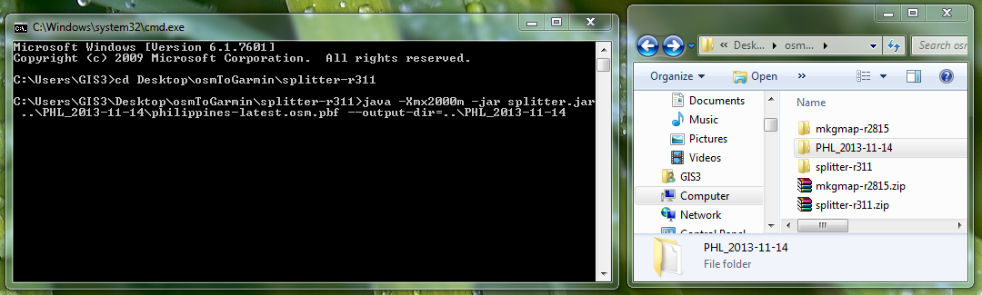

- Check your data folder (PHL_2013-11-14 in this example), it should contain a series of files that begin with 6324 and have the file extension *.osm.pbf
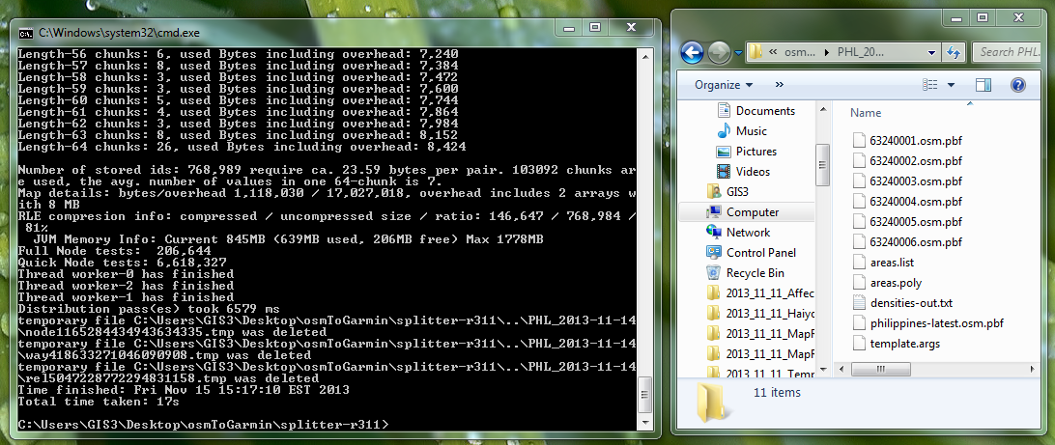

- Change directory to your data folder
cd ..\PHL_2013-11-14
- Run mkgmap to compile the files
java -jar ..\mkgmap-r2815\mkgmap.jar --gmapsupp 6324*.osm.pbf

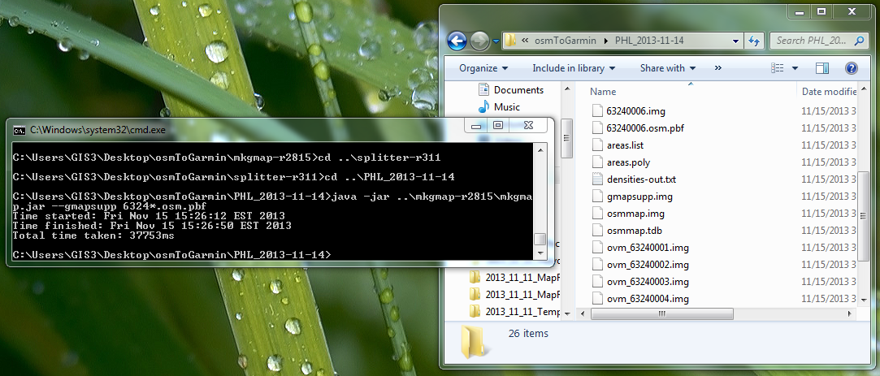
- Connect your Garmin device and copy the gmapsupp.img file into the ‘Garmin’ folder on the Garmin’s internal memory (not the SD card if one is in the device). If no such folder exists, create it.

